**ASSIGNMENT 2 (HTML & CSS)**

1. **Define the terms: Website, Webpage, Web browser, Web server, HTML, CSS**.

**Website : It's a collection of webpages grouped together under a single domain name. Websites can contain text, images, videos, and more.**

**Webpage: A webpage is like a single page in that digital book (the website). It's what you see on your screen when you visit a website. Webpages are made up of text, images, links, and other content.**

**Web browser : A web browser is like a magic window that you use to view webpages on the internet. Examples of web browsers include Chrome, Firefox, and Safari. You type a web address (URL) into your browser, and it shows you the webpage.**

**Web server : When you type a web address into your browser, the browser sends a request to a web server. The server then fetches the webpage you asked for and sends it to your browser.**

**HTML : HTML is a Hypertext Markup Language. HTML is like the language of webpages. It's a set of instructions used to create the structure of a webpage. HTML tells your browser what text is, where images go, and how to create links.**

**CSS : CSS is a Cascading Style Sheet. CSS is like the fashion designer for webpages. It's used to control how webpages look. With CSS, you can change colors, fonts, layouts, and more to make webpages visually appealing.**

1. **Create a webpage to show “This is my first HTML page”**

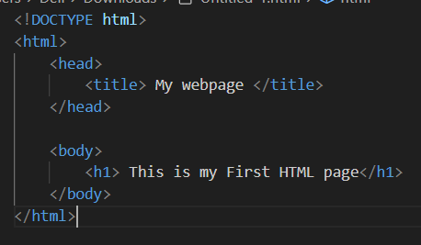

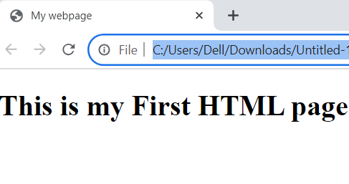

1. **Display top 10 IT companies list in html webpage.**

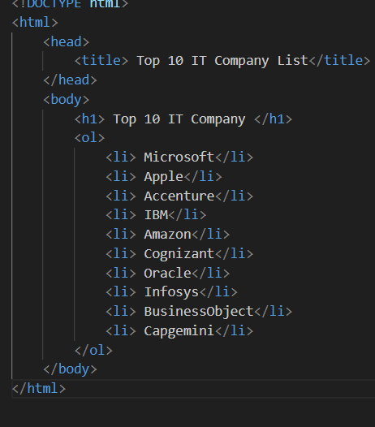

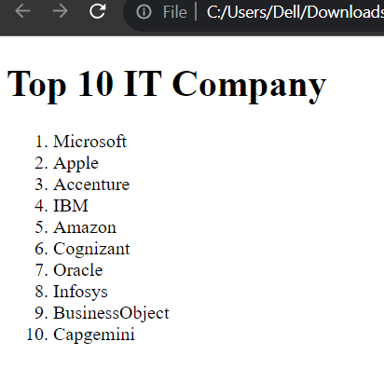

1. **Create a dropdown list.**

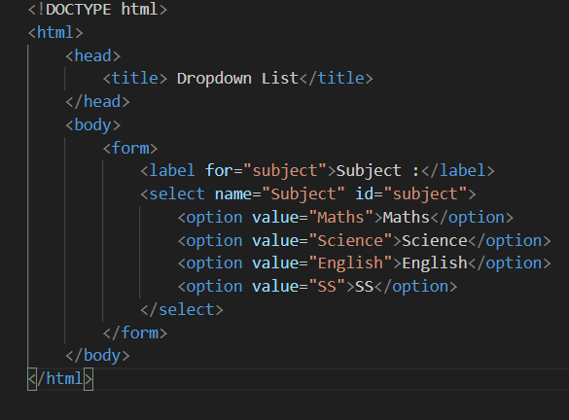

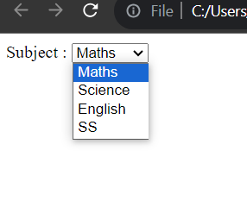

1. **Create a Table Of college Management system using row span & col span.**

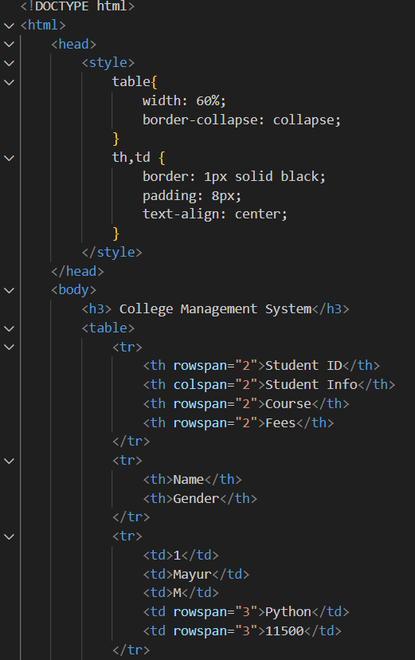

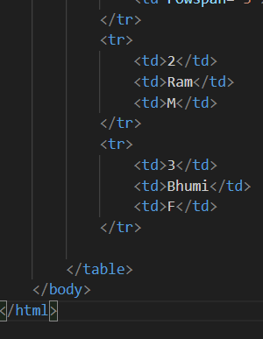

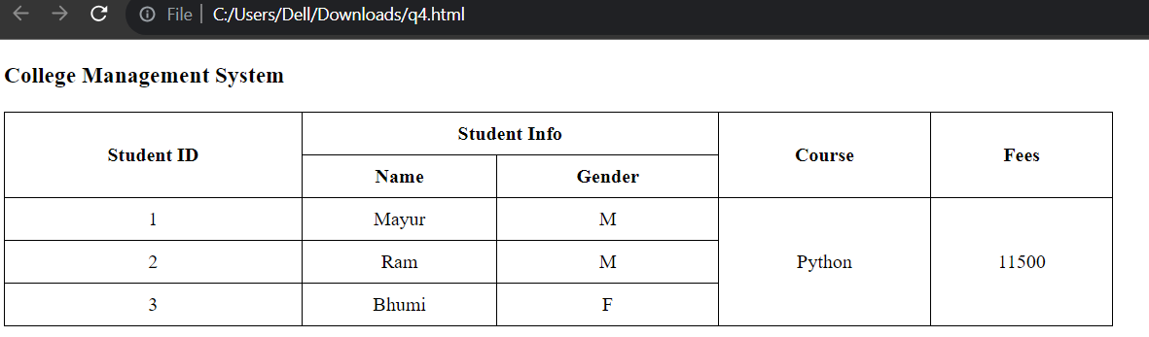

1. **Create below table using HTML table tags.**

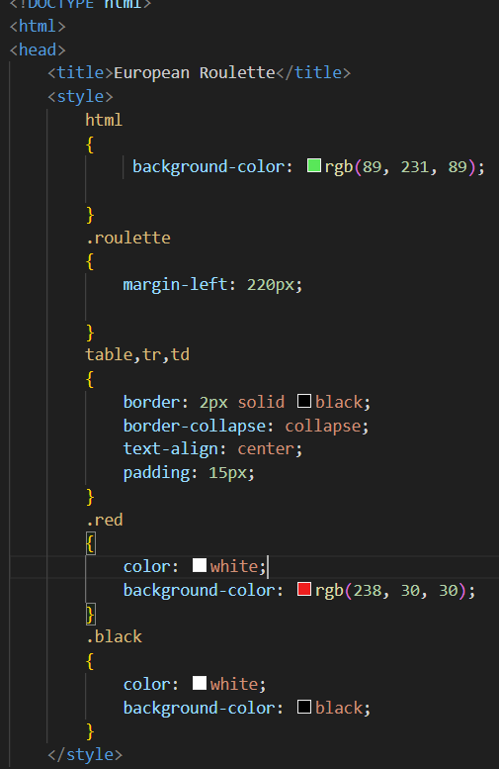

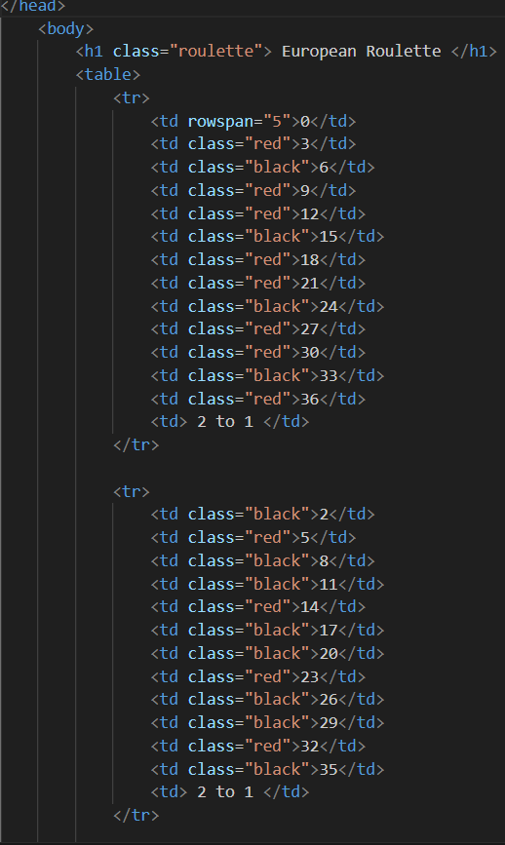

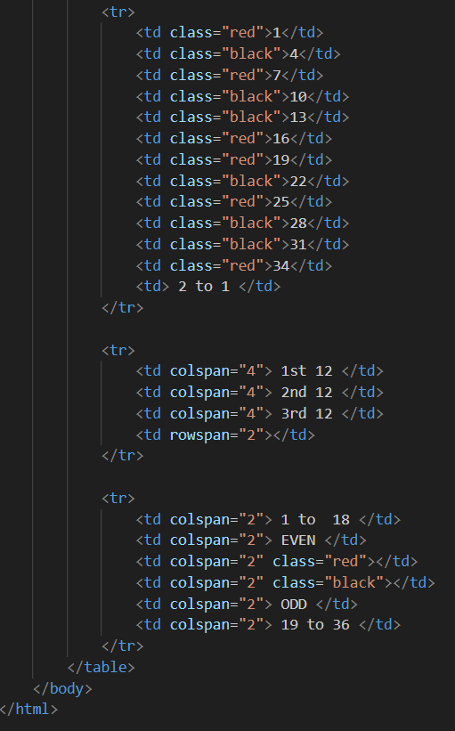

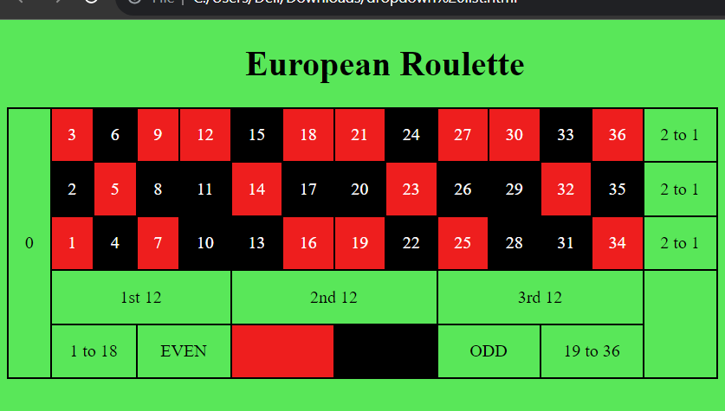

1. **Create Registration form using HTML, CSS.**

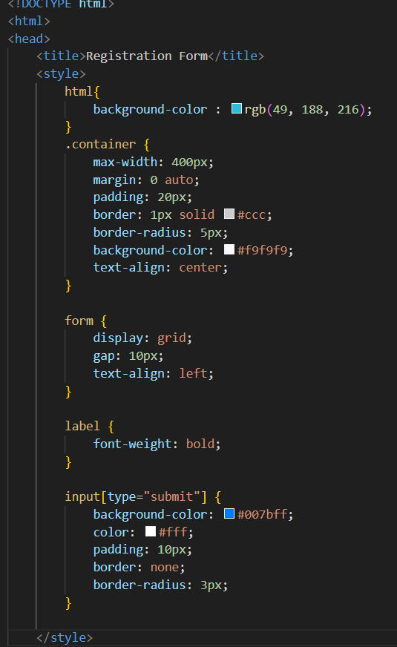

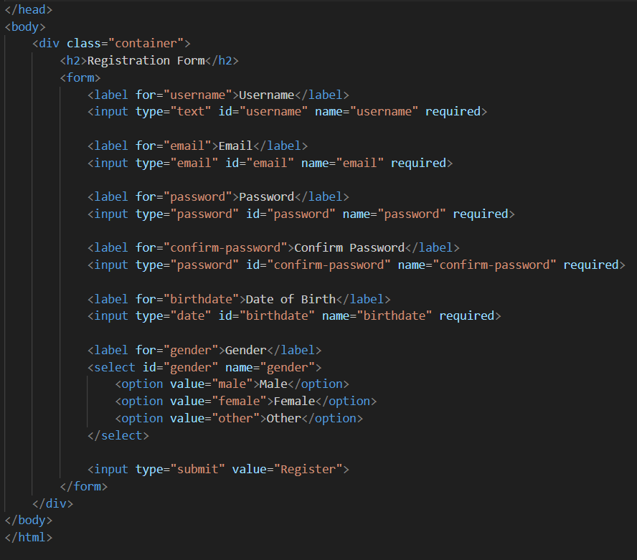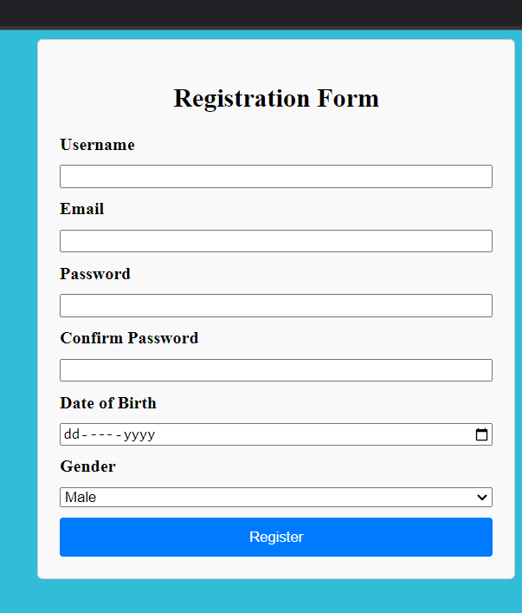

1. **In how many ways can a CSS be integrated as a web page?**

**There is a three type of CSS can be integrated in a webpage.**

1. **Inline CSS : You can include CSS directly within an HTML element using the style attribute.**

**For example:**

**<p style= color:”red;” > inline css </p>**

1. **Internal CSS : You can include CSS rules within a <style> element in the <head> section of an HTML document. This method applies the defined styles to the entire HTML document.**

**For example:**

**<head>**

**<style>**

**p {**

**color: red;**

**font-size: 12px;**

**}**

**</style>**

**</head>**

**<body>**

**<p> This is internal CSS </p>**

**</body>**

1. **External CSS** : **You can create a separate CSS file (usually with a .css extension) and link it to your HTML document using the <link> element. This method allows you to apply the same styles to multiple HTML pages.**

**<head>**

**<link rel="stylesheet" type="text/css" href="styles.css">**

**</head>**

**<body>**

**<p>This is external CSS </p>**

**</body>**

**External CSS file “style.css”:**

**p {**

**color: red;**

**font-size: 20px;**

**}**

**These are the primary methods for integrating CSS into a web page.**

**(9) Create simple three pages using External CSS, Internal CSS, and Inline CSS.**

**(1) Internal CSS:**

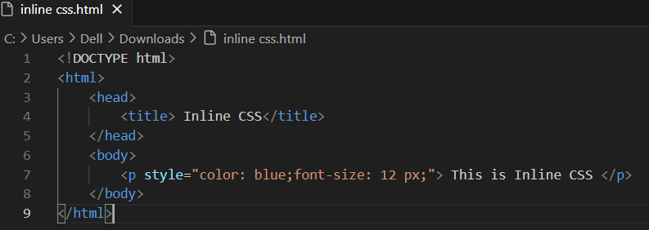

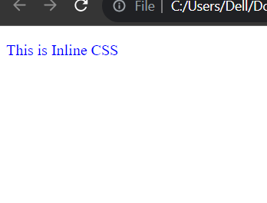

**(2) Internal CSS :**

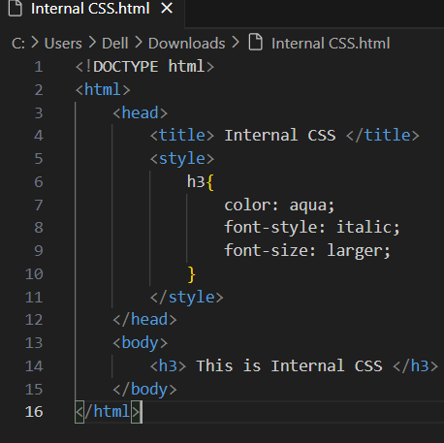

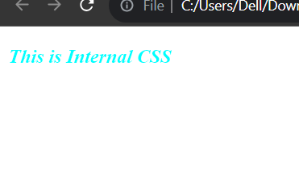

1. **External CSS :**

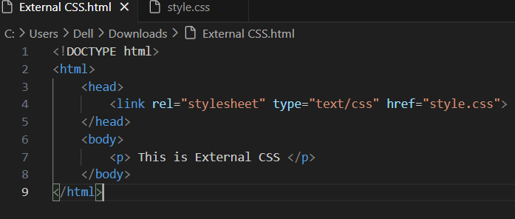

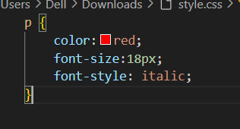

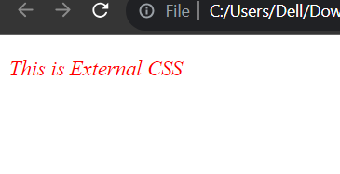

**(10)** Create below page using HTML CSS.

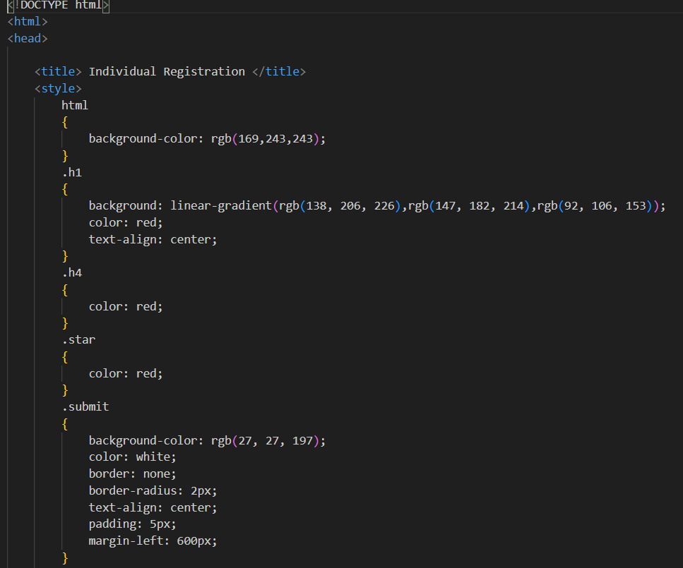

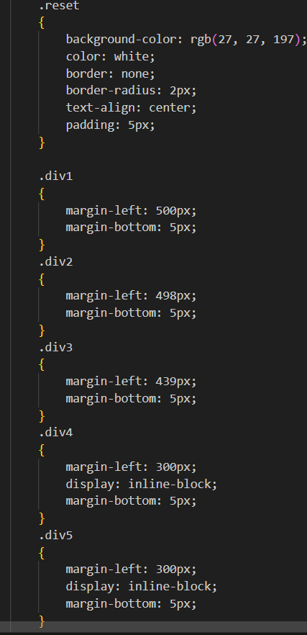

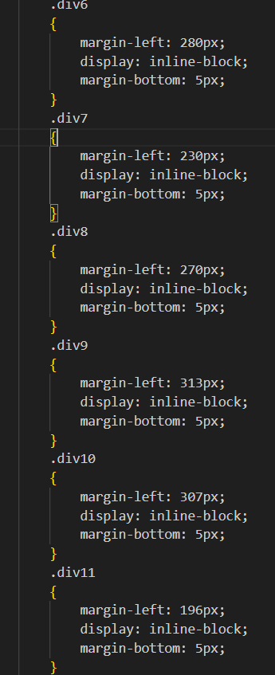

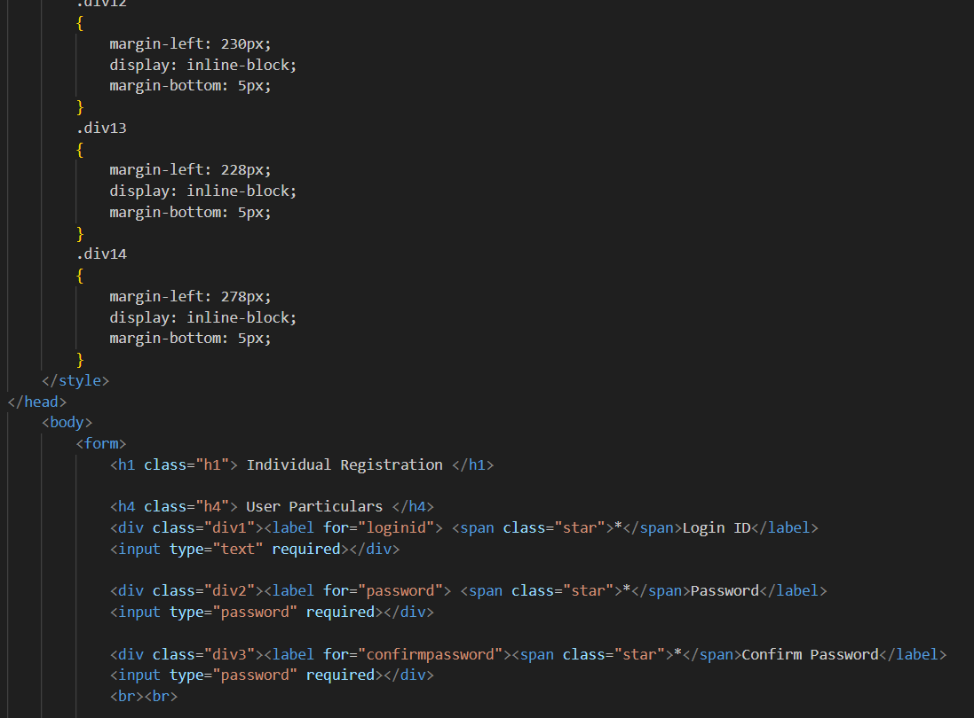

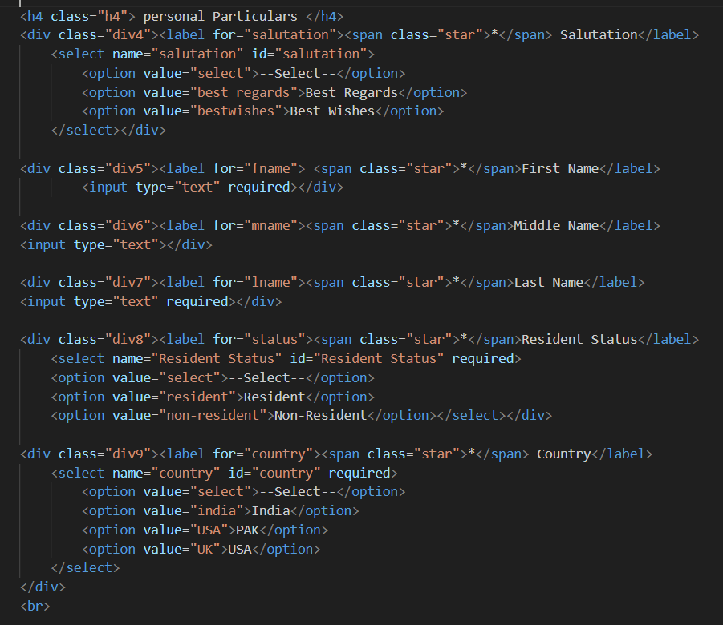

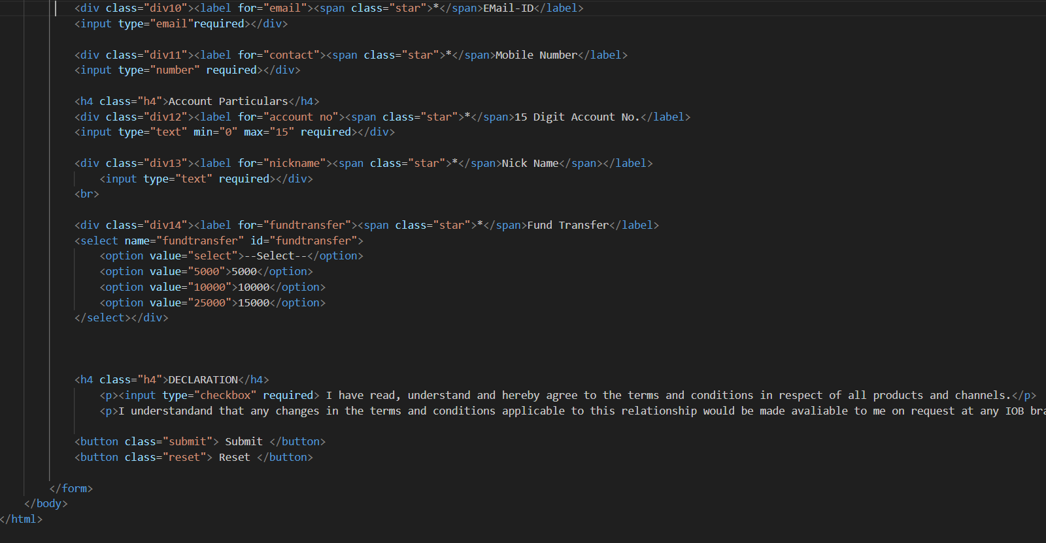

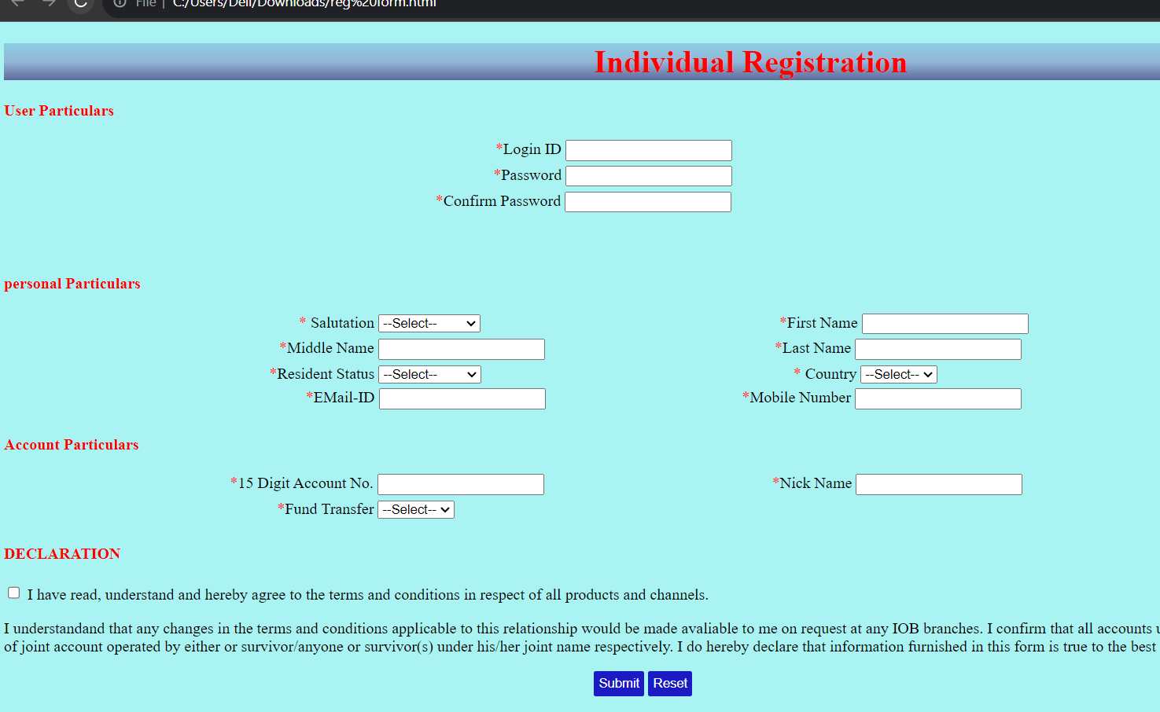

**(11) Create link-pseudo classes using external css, to format links on the pages.**

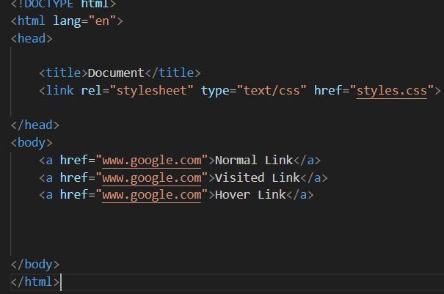

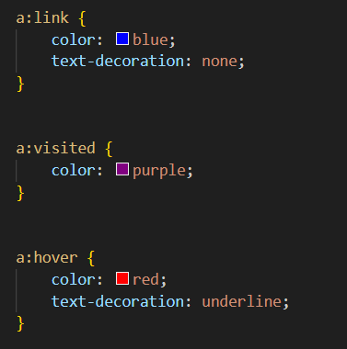

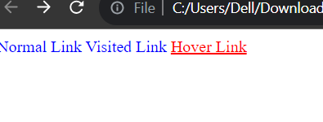

**(12)** Create a dynamic pseudo class using HTML, CSS.

